**Introduction to Databases (Spring 2020)**

**Homework #1 (40 Pts, April 29, 2020)**

**Student ID 2016312761**

**Name 여혁수**

**(1) [10 pts]** Consider the AIRLINE relational database schema, which describes a database for airline flight information. Each FLIGHT is identified by a *Flight_number*, and consists of one or more FLIGHT_LEGs with *Leg_number*s 1, 2, 3, and so on. Each FLIGHT_LEG has scheduled arrival and departure times, airports, and one or more LEG_INSTANCEs— one for each Date on which the flight travels. FAREs are kept for each FLIGHT. For each FLIGHT_LEG instance, SEAT_RESERVATIONs are kept, as are the AIRPLANE used on the leg and the actual arrival and departure times and airports. An AIRPLANE is identified by an *Airplane_id* and is of a particular AIRPLANE_TYPE. CAN_LAND relates AIRPLANE_TYPEs to the AIRPORTs at which they can land. An AIRPORT is identified by an *Airport_code*.

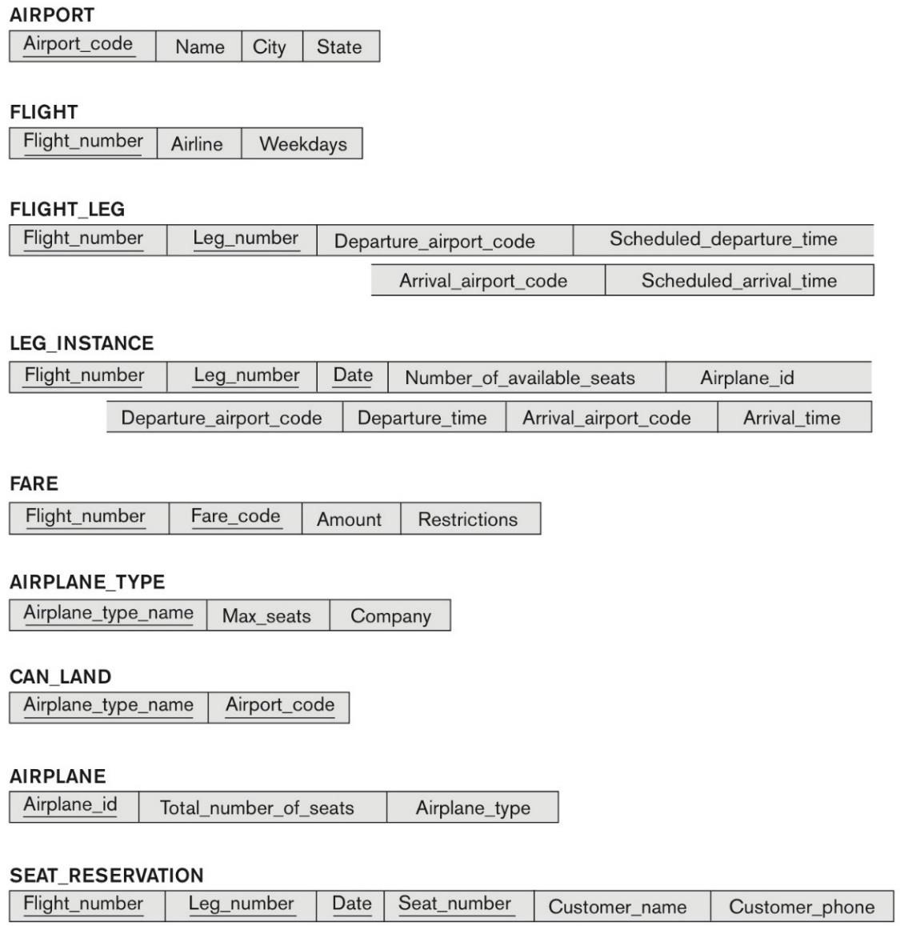

Specify all the referential integrity constraints that hold on the schema.

**Ex) Table_name.column (FK) -> Table_name for PK**

FLIGHT_LEG.FLIGHT_NUMBER --> FLIGHT

FLIGHT_LEG.DEPARTURE_AIRPORT_CODE --> AIRPORT

# Answer

|  |
| --- |
| **FLIGHT_LEG.Flight_number->FLIGHT**  **LEG_INSTANCE.Flight_number->FLIGHT**  **LEG_INSTANCE.Leg_number->FLIGHT_LEG**  **LEG_INSTANCE.Departure_airport_code->FLIGHT_LEG**  **LEG_INSTANCE.Departure_time->FLIGHT_LEG**  **LEG_INSTANCE.Arrival_airport_cod->FLIGHT_LEG**  **LEG_INSTANCE.Arrival_time->FLIGHT_LEG**  **FARE.Flight_number->FLIGHT**  **SEAT_RESERVATION.Flight_number->LEG_INSTANCE**  **SEAT_RESERVATION.Leg_number->LEG_INSTANCE**  **SEAT_RESERVATION.Date->LEG_INSTANCE**  **AIRPLANE.Airplane_type->AIRPLANE_TYPE**  **LEG_INSTANCE.Airplane.id->AIRPLANE**  **CAN_LAND.Airplane_type_name->AIRPLANE_TYPE**  **CAN_LAND.Airport_code->AIRPORT** |

**(2)** [**10 pts**] Consider the ER schema for the MOVIES database as below. In the ER schema, ACTOR is used as a generic term and includes actresses. Given the constraints shown in the ER schema, answer the following statements with *true* or *false*. Explain why.

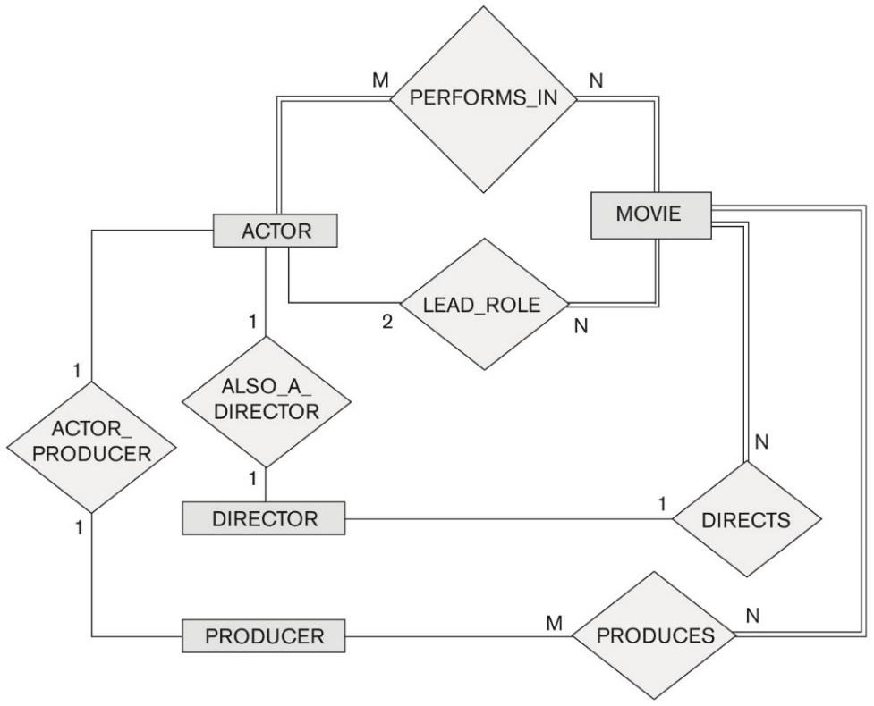

**(a)** There are no actors in this database that have been in no movies.

# Answer

|  |
| --- |
| **True, because ACTOR entity has a relationship that is total participation with MOVIE entity.** |

**(b)** A movie can have no lead actor.

# Answer

|  |
| --- |
| **False, In LEAD_ROLE relationship, MOVIE entity has a relationship that is total participation with ACTOR entity. That means all tuples of MOVIE indicates some of tuples of ACTOR.** |

**(c)** Every director has been an actor in some movie.

# Answer

|  |
| --- |
| **False, In ALSO_A_DIRECTOR relationship, it is 1:1 cardinality ratio relationship, and DIRECTOR entity doesn’t have total participation to ACTOR entity. So there are some director who have not been an actor.** |

**(d)** An actor can be a director and producer at the same time.

# Answer

|  |
| --- |
| **True, reason why an actor can be a director explained by question(c), and also ACTOR entity has 1:1 relationship with PRODUCER entity, so an actor can be a director and producer at the same time.** |

**(e)** Every producer has been an actor.

# Answer

|  |
| --- |
| **False, In ACTOR_PRODUCER relationship, PRODUCER entity is not total participation to ACTOR entity. So some producers might have not been an actor.** |

**(f)** A movie has one director, but many producers.

# Answer

|  |
| --- |
| **True, it is true that whichever we chose a movie, it has only one director because MOVIE entity has N:1 & total participation relationship with DIRECTOR relationship. Also, a movie can have many producers, because MOVIE and PRODUCER entities have M:N relationship.** |

**(g)** Every movie has a director who also acted in that movie.

# Answer

|  |
| --- |
| **False, by solution of question(c), there can be some director who is not actor. In same way, every movie can’t have a director who also acted in that movie.** |

**(h)** A producer cannot be an actor in some other movie.

# Answer

|  |
| --- |
| **False, PRODUCER & ACTOR entities have 1:1 relationship, so a producer can be an actor and by solution of question(a), all actors participate in some movie. So, a producer can be an actor in some other movie.** |

**(i)** Every producer should produce one or more movies.

# Answer

|  |
| --- |
| **False, PRODUCER entity has partial participation with MOVIE entity. So there is a producer who does not make any movie.** |

**(j)** A movie can have two lead actors.

# Answer

|  |
| --- |
| **True, because ACTOR & MOVIE entities have 2:N relationship with total participation of MOVIE entity in LEAD_ROLE relationship. So there is a movie which has two lead actors.** |

**(3) [10 pts]** Consider the following ER diagram for the BANK database. Each bank can have multiple branches, and each branch can have multiple accounts and loans.

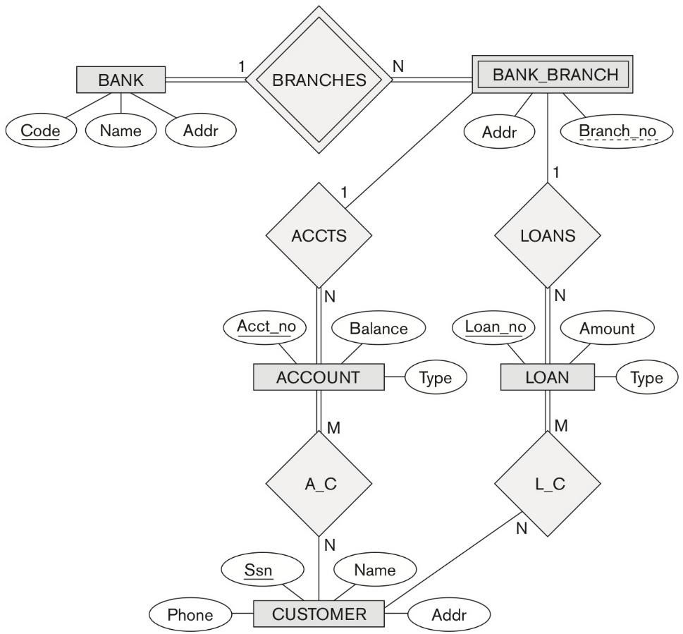

**(a) [1 pt]** List the regular entity types in the ER diagram.

# Answer

|  |
| --- |
| **[BANK, ACCOUNT, LOAN, CUSTOMER]** |

**(b) [2 pt]** Is there a weak entity type? If so, specify the primary key for the weak entity type.

# Answer

|  |
| --- |
| **Yes, BANK_BRANCH entity is weak entity. It has weak relation with BANK entity, so primary key is an attribute named Code and Branch_no, which is primary key of BANK entity and BANK_BRANCH entity each.** |

**(c)** [**7 pts**] Map the BANK diagram into a relational model. For each relation, specify all primary keys and foreign keys.

**Answer:**

BANK

|  |  |  |
| --- | --- | --- |
| Code | Name | Addr |

BANK_BRANCH

|  |  |  |
| --- | --- | --- |
| BCode | Branch_No | Addr |

ACCOUNT

|  |  |  |  |  |
| --- | --- | --- | --- | --- |
| AcctNo | Balance | Type | BCode | Branch_No |

Customer

|  |  |  |  |
| --- | --- | --- | --- |
| SSN | Name | Phone | Addr |

LOAN

|  |  |  |  |  |
| --- | --- | --- | --- | --- |
| LoanNo | Amount | Type | BCode | Branch_No |

A_C

|  |  |
| --- | --- |
| SSN | ACCTNo |
| L_C |  |
| SSN | LoanNo |

**(4) [10 pts]** Consider the ER diagram for SHIP_TRACKING database to keep track of transport ships and their locations for maritime authorities. Map this diagram to a relational schema (SHIP, SHIP TYPE, PORT, PORT_VISIT, SHIP_MOVEMENT, STATE_COUNTRY, SEA_OCEAN_LAKE), and specify all primary keys and foreign keys for each relation.

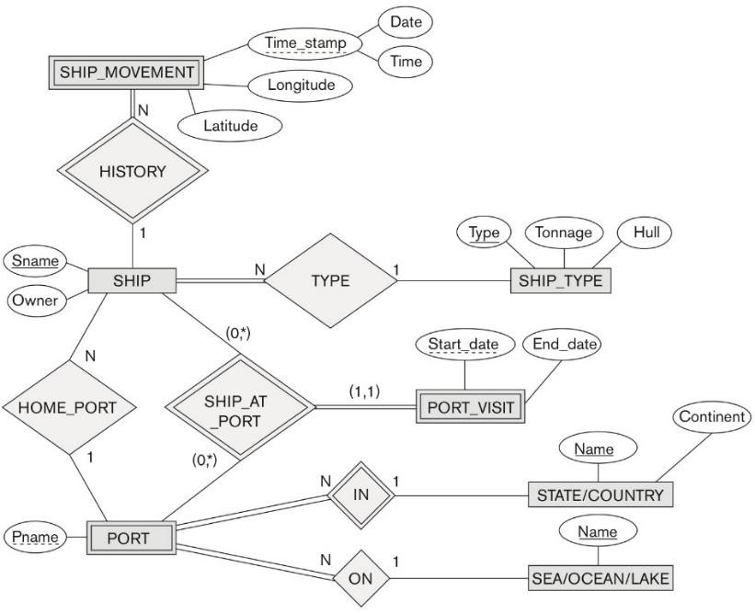

# Answer

|  |  |  |  |  |  |  |  |  |  |  |  |  |  |  |  |  |  |  |  |  |  |  |  |
| --- | --- | --- | --- | --- | --- | --- | --- | --- | --- | --- | --- | --- | --- | --- | --- | --- | --- | --- | --- | --- | --- | --- | --- |
| **SHIP_MOVEMENT**   |  |  |  |  |  | | --- | --- | --- | --- | --- | | Sname | Longitude | Latitude | Date | Time |   **SHIP**   |  |  |  |  | | --- | --- | --- | --- | | SName | Owner | Type | Pname |   **SHIP_TYPE**   |  |  |  | | --- | --- | --- | | Type | Tonnage | Hull |   **PORT**   |  |  |  | | --- | --- | --- | | Pname | State_Name | Sea_Name |   **PORT_VISIT**   |  |  |  |  |  | | --- | --- | --- | --- | --- | | Start_date | End_date | Sname | Pname | State_name |   **STATE/COUNTRY**   |  |  | | --- | --- | | Name | Continent |   **SEA/OCEAN/LAKE**   |  | | --- | | Name | |